The Cathedral School of St Mary

Behaviour Policy 2017

Mission Statement

Together we will:
- promote a catholic ethos of caring and forgiveness;
- nurture the intellectual, spiritual, moral, social and physical development of each person;
  - be free to express ourselves in a safe environment;
- share in the life of our family, school and community.

Express, Forgive, Care, Share, Nurture
And never forgetting that, ‘God made me as I am’

Principles

At The Cathedral School we value the excellent behaviour of our pupils and expect all school members; staff, children, visitors and parents to model good behaviour as we recognise that we are all made in God’s image and therefore we strive to treat one another as we would like to be treated ourselves.

When discussing behaviour we are all clear that we do not just mean an absence of negative behaviour but the presence of positive behaviour and learning. We value effort and learning from our mistakes in all areas.

We aim:
- To encourage self-control, respect for others; respect for classroom resources, other people’s property and our school environment so that each child learns to accept responsibility for his/her own behaviour
- To raise awareness of appropriate behaviour and make boundaries of acceptable behaviour clear
- To foster positive, caring attitudes towards everyone where achievement at all levels are acknowledged and valued
- To ensure that expectations are clear and to ensure safety.
- To encourage a calm, purposeful and happy atmosphere within the school.
- To have a consistent approach to behaviour throughout the whole school (and whole school day) with parental cooperation and involvement.
Our school rules are simple and easy to remember and all staff work to ensure that they are understood by all:

- We use kind hands
- We use kind words
- We respect adults, children and property
- When we are finding things difficult we ask for help

Class rules are additional to this and decided by the children and individual teacher. They are specific and positive. We recommend having a maximum of 3 so the children can remember and value these rules

Promoting Good Behaviour
At Cathedral School we promote good behaviour through providing clear messages and ensuring that all adults are excellent role models. Our FAITH learning behaviour strategy clearly identifies the school’s aims for children’s wider behaviour and learning. It exemplifies ‘what we do here’.

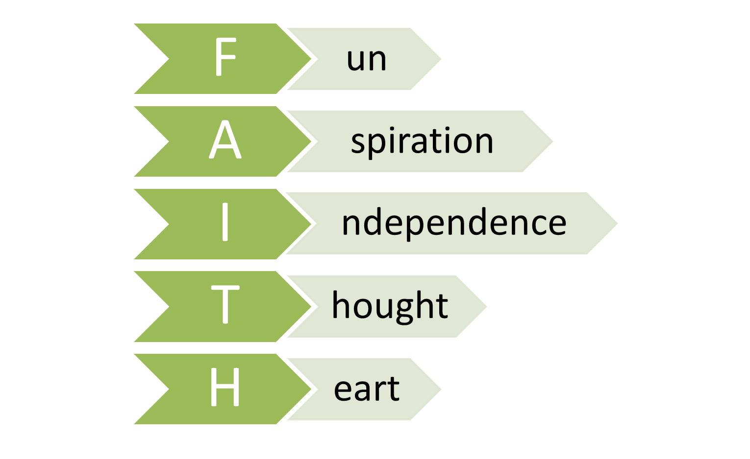

Masses and Assemblies
All masses and assemblies (class, key stage, whole school) are used as an opportunity to promote the Catholic ethos of the school through supporting Personal, Social and Health Education and the celebration of children’s work, talents and achievements. Parents and visitors are warmly invited to join in any of our celebrations.

Around the school
Children will enter school as they arrive- at anytime from 8.45; they should all arrive by 8.50. The classrooms will be manned and a morning activity will be waiting for the class. At breaktimes, lunchtime and transitions through the day the children will be expected to move around the school quietly and sensibly.

In the playground
To ensure the children’s playtimes are happy, safe and pleasant we ensure that -

- children are taught co-operative games by teaching staff
- toys from home are not permitted as this causes arguments and sadness if the toy is damaged by peers
- incidents of fighting, bullying and name-calling are dealt with immediately by all staff and referred to the teacher or head teacher as appropriate
- the children stand still when the bell is rung at the end of playtime and lunch break until the teacher on duty sends them sensibly to their class (the bell is rung 5 mins prior to the end of break and lunch to help children with SEN and behaviours issues)
- children stand silently in line
- the children show respect for our SMSAs
- there is liaison between SMSAs and teaching staff over children’s behaviour and well-being through the behaviour book

Managing Classroom Behaviour
All children have the right to learn without being interrupted or disrupted. All teachers have the right to teach without interruption or disruption and all staff will work to support children to ensure that each are able to do so.

School Responsibility
We believe it is important that the class work as a unit. As a prerequisite to good discipline in the classroom we make sure that our pupils are aware of the structure and organisation of the day and resources are well labelled and accessible for use. In addition to this we -

- differentiate work and activities where appropriate
- comment on good work and praise good behaviour privately and publicly
- insist on appropriate noise levels relevant to the task being carried out
- raise awareness of health and safety issues for the benefit of pupils themselves and their peers
- make clear expectations of good behaviour
- promote mutual respect by personal example and discouraging unsociable behaviour
- encourage children to take responsibility for their own actions and behaviour
- inform parents of positive achievements and behaviour
- Establish whole class and individual systems for rewarding good behaviour

In order to maintain an effective discipline structure we –
- Attempt to redirect the inappropriate behaviour by referring to positive behaviour near by
- ask the child if s/he needs help or support
- ask the child(ren) what they should have been doing or have done
- tell the child that when they (specify the inappropriate behaviour e.g. when you call out) it has (state the effect e.g. you find it hard to concentrate) this effect on you
- encourage the children to take responsibility for their own behaviour
Parental Responsibility:
- To be aware of the school rules and expectations
- To make children aware of expected behaviour in all situations
- To encourage independence, resilience and self-discipline
- To show an interest in all that their child does in school
- To foster good relationships with the school
- To support the school in the implementation of this policy

The behaviour system:
Each class has their own traffic light system with pegs regarding behaviour, and this will be visible in the classroom to all of the children. Every child will have a peg with their name on which will start on the green light at the beginning of every new session (after play, after lunch).
Gold - Throughout the day children will have every opportunity to advance to ‘gold’. This marks exceptional behaviour or learning for the individual and will be acknowledged by informing parents. (see appendix 3)

Green - The value of constantly remaining at ‘green’ must not be underestimated – this signifies a major personal learning achievement and children will be encouraged to value the self-satisfaction which this brings.

Amber - Children will be made aware that either their behaviour has slipped below what is expected and she/he will be given an opportunity to change this.

Red 1st time - When a child’s behaviour slips below what is expected (amber) and they repeatedly display the same behaviour, despite adult support, they are to be moved to red and 10 minutes of break/lunch will be missed. Should an incident occur at end of the day the child will be required to complete work at home (see appendix 4).

In all cases, teachers are to speak with parents. When teachers speak to parents, they should be invited into the classroom, not advised on the playground. If the parent does not collect the child, a phone call is to be made that day.

2nd Red- Parents and child are to meet with the Head of Learning at the earliest opportunity.

3rd Red - Parents and teachers to meet with the Executive Head to keep a record.

Children will know that they can come off Red during the day, but once this step has been reached, parents will be informed and CPOMS (our safeguarding database) updated. Each half term begins anew.

EYFS
Parents are told whenever their child reaches the bottom of the ladder and when they are still at the top at the end of the day. The Head of Learning is to be made aware of persistent offenders.

Severe Behaviour:
The following list contains some examples of behaviour which will not be tolerated in this school.
- Violent behaviour
- Severe verbal abuse
- Wilful damage to property or premises
- Theft
- Failure to comply with school safety rules

Such behaviour is extremely serious and will be dealt with immediately by a Senior Leader (straight to red). The offending child’s parent will be informed and, depending on the seriousness of the incident, matters may be taken further.

Emergencies
In an emergency staff may send a reliable pupil with a red triangle to a senior member of staff. If this is not possible, remove the remaining pupils from the ‘situation’ by sending them to a supervised/safe area. Use de-escalation techniques to calm the situation. In exceptional circumstances, restraint may need to be used. Teachers also have the power to discipline children even when they are not in school, or under the direct charge of a member of staff.

Timeout

Time out for reflection
In order to get their behaviour back on track, some children may need to take a time out to calm down or think. This type of time out is not a punishment and can be suggested by teacher or the student. These types of time out are given purely at the discretion of teaching staff, should only be for a few minutes and do not require the pupil to go to another class. Teachers need to address any issues once the child returns to work.

Time out for behaviour
Having followed the traffic lights system, and where children’s behaviour fails to improve and they are moved to red, a time out may be necessary. If this should happen, teachers are to give the child a piece of work at the appropriate level for them to do whilst they are out. Children are to take the 5 minute timer to another class, preferably the one below their year group. Reception should only use time out in extreme circumstances.

When children return to class, they are expected to apologise for the interruption and make amends by showing expected behaviours.

Lunchtime
The school rules are also relevant to lunchtimes. However, rewards will be an MTA award where the child’s name goes into an infant and junior raffle which is drawn each Friday. Sanctions, will include time out of play, against a wall for 5 minutes using a timer. This will be recorded in the playground log and the Head of Learning made aware of persistent offenders.

Positive Handling
In extreme circumstances, after all attempts to de-escalate a situation have been tried, and where there is a risk of a child hurting themselves or others, staff will follow the DfE (2013) Advice on the use of reasonable force. Staff will receive training to ensure that all actions focus on the safety of the child and follows these guidelines. At all times staff will continue to talk to the children reassuring them and attempting to de-escalate the situation.
Positive handling can only be deemed reasonable if:
- it is warranted by the particular circumstances of the incident
- it is delivered in accordance with the seriousness of the incident and the consequences which it is desired to prevent
- it is carried out as the minimum to achieve the desired result
- the age, understanding and the gender of the pupil are taken into account
- it is likely to achieve the desired result. Wherever possible, assistance will be sought from another member of staff before intervention.

The form of physical intervention may involve staff doing the following:
- physically interposing themselves between pupils
- blocking a pupil’s path
- escorting a pupil
- shepherding a pupil away
Any such measures will be most effective in the context of the overall ethos of the school, the way in which staff exercise their responsibilities and the behaviour management strategies used.

Recording
Where positive handling has been used a record of the incident always needs to be kept. All recording needs to be completed on the day of incident and needs to include the following:
- name of pupil
- date, time and place of incident
- a brief description of the incident and actions taken
- attempts made to calm the situation
- names of people who witnessed the situation
- any damage/harm to persons or property
- name of person informing parents

Monitoring of Incidents
Whenever a member of staff has occasion to use positive handling, this will always be recorded and documented. Monitoring of incidents will help to ensure that staff are following the correct procedures and will alert the Head of Learning and/or Executive Headteacher to the needs of any pupil(s) whose behaviour continues to raise concern. This process will address patterns of incidents and evaluate trends which may be emerging.

Complaints
Any complaints about staff or the behaviour policy will be dealt with under the school’s Complaints Policy.

Rewards
We have high expectations at The Cathedral School and consider that doing the right thing is its own reward. Whilst good behaviour is expected to be the norm staff will recognise particular examples of good behaviour through awarding:

Dojo points/House points
Dojo points can be given for a variety of reasons but will generally be for demonstrating good learning behaviour and/or care of others. Dojo points translate into house points and each week teachers are to total the points for each house. The team with the most house points is celebrated in assembly on Friday and have an extended playtime on Monday.

Effort award
Weekly certificates are given out each Friday during the whole school assembly. These are to celebrate an achievement (learning, effort, resilience and/or the FAITH learning behaviours – something that is exceptional for that individual). Staff keep their own records for this. The reason for the award is written on the certificate.

Courtesy Award
The demonstration of good manners is rewarded by a courtesy award which is celebrated at a tea party once per term hosted by either the Executive Headteacher or Head of Learning.

Class Rewards
In addition to the above, individual class teachers may have their own reward system in place to encourage good whole class behaviour.

FAITH Afternoon
At the end of each short term we hold a celebration and team building afternoon linked to the curriculum and the value and importance we place on fun, aspiration, independence, thought and heart.

Agreed by Governors on:

Chair of Governors:

To be reviewed in: September 2017

Appendix 2

Strategies to support green behavior | - Be prepared for the day/lesson – reduce time waiting.  - Pre-teach vocabulary/subject to children likely to disrupt the class when they struggle.  - Praise for academia and social expectations  - Praise individuals/groups/class for appropriate volume.  - Give regular reminders of behavior/volume level.  - Highlighting positive examples to the rest of the class - encouraging others to imitate, ‘Well done for following the class rule/school rules on ……………….’  - Resources, use dojos/house points for everything, class rewards, highlighting positive behaviours to SMT.  - Set challenges within tables to gain the most behavior points, etc.  - Giving children specific roles and responsibilities and encouraging children to enjoy being at school  - Set a time-specific target during which to demonstrate positive behaviours. Focus on children 'owning' their behaviours, positive, calm - though still firm.

At every stage the aim of all adults will be to pre-empt negative behaviours and promote positives; a child moving to amber is a signal the teacher that action to change behaviour needs to take place.

Strategies to support amber behaviour | - Speak quietly/privately with the child  - Enable the child to identify what when wrong, and what they can do to make it right. Focus on children 'owning' their behavior. ‘What can you do to make it right? How can we get back to green?’ Ask a friend how they could get back e.g ‘wouldn't it be nice if A could get back to orange so he can come out for play time? How can you help him B? What advice would you give him?’  - Ask them is there is a reason why they made that choice. ‘Are you finding the task challenging? Why don't we try doing this while instead?’ Discuss with the child and/or introduce resources to aid with work  - Set a time-specific target during which to demonstrate positive behaviours. Focus on praising the appropriate behaviours elsewhere, so all children know what it looks like.  - Praise for each positive thing so they know they are heading in the right direction,  - Use distraction, ‘the look’, verbal request for what you want them to do (trying to avoid ‘don’t’).  - Use reminders to refocus child.  - Change teaching style, sensory space.  - Forced compliance (requesting a child to do a minor thing then asking for what is really wanted, e.g. will you pick that up and then…)  - Getting the child to visualise what they should be doing by asking ‘Are you alright ………..? What should you be doing? Where should you be?’

Appendix 1

Traffic Lights | Explanation of level | Action to be taken
WOW | - Children have achieved exceptional levels of behaviour and/or learning | WOW Certificate
On Task | - Children are behaving and/or learning at an expected level  - Everyone is on green at the beginning of the day, after play and after lunch | Class recognition/reward/dojo - classes to decide own reward  Children previously on red should have missed 10 minutes of play and can move back to green, but parents still need to be contacted.
Action | Behaviour and/or learning has slipped below what is expected and children will be given an opportunity to change their behaviour | Teacher to take action to help child change behaviour See Appendix 2  Time out to reflect can be agreed with child. This is not a move to red
Speak with Parents  1st time | Behaviour and/or learning has repeatedly slipped below what is expected despite adult support. | 10 minutes of break/lunch will be missed.  If this happens at the end of the day they will be required to complete work at home after speaking with the teacher see appendix 4  5 minute time out can be given - child remains on red until behaviour improves  Speak to parents even if the child gets him/herself back into the green.  When speaking to parents, invite them into the classroom, do not advised on the playground. If the parent does not collect the child, a phone call is to be made that day.
2nd Red | Behaviour and/or learning has repeatedly slipped below what is expected despite adult support, and this is the 2nd time in a half term. | Parents and child are to meet with the Head of Learning at the earliest opportunity.
3rd Red | Behaviour and/or learning has repeatedly slipped below what is expected despite adult support, and this is the 3rd time in a half term. | Parents and teachers to meet with the Executive Head to keep a record.

Appendix 3

Congratulations! Today ________________________

got on “WOW!” because they showed behaviour or learning that was exceptional to them by:

___________________________________________________

___________________________________________________

___________________________________________________
Date __________Signed______________________________

