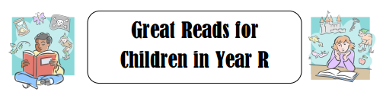
Want to buy your child a book for Christmas but not sure what is suitable for their age range? Look no further for a great list of books that, not only will your child enjoy, but will also support and develop their reading.
All books that appear on this list have been chosen from the recommended reading list for Reception published by the Centre for Literacy in primary education, and are available on Amazon.
